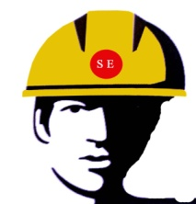
MOB : 9811048483

(A UNIT OF SHIVA INDUSTRIAL CORPORATION)
Email : rahulsakhuja@yahoo.com, safetyexpertssales@gmail.com

4614-15, GALI SHAHTARA, AJMERI GATE, DELHI - 110006

COMPANY INTRODUCTION
Safety Experts is a one-stop-shop, which has been set up to provide you with the best Personal Protective Equipments and Road Safety. We are the whole seller, importer, dealer and supplier of wide range of Personal Protective Equipments, under the Brand Name “Freefall” “ Unisafe”


We have a wide range of products which consist of Safety Helmets, Safety Goggles, Face Shields, Ear Plugs & Ear Muffs, Safety Hand Gloves, Body Protection Suits, Fire & Heat Protective Clothings, Respiratory Protection, Safety Shoes, Fall Protection, Alluminium Safety Ladders, Construction Safety Nets, Protection against Industrial Hazards, Welding Curtains & Fire Blankets, Emergency Safety Shower, Emergency Eyewashes, Industrial Fabrics & Technical Textiles, Road Safety Products, Fire Fighting Products, Security Products, Lockout Tagout Products, Industrial Lifting Equipments.

Our Vision is to provide quality safety products and services with on-time delivery, competitive prices and after-sales services. We are a customer centric firm and our main focus is to deliver what the customer needs. Each requirement is carefully addressed and a prompt response guaranteed.


Our Mission is to protect and improve worker lives who are working under hazardous industrial areas and Environment. We shall achieve this by providing the finest quality safety products. Our range of safety products
are widely used in different segments of industries such as Iron and Steel, Construction, Cement, Petrochemicals, Fabrication, Power Plants, Glass, Paper, Mining, Hospitality Services, Chemicals and Fertilizes etc. Our major markets of supply are domestic market (all over India).

We supply all products manufactured as per Indian and International standards.

Given below some pics of the products:
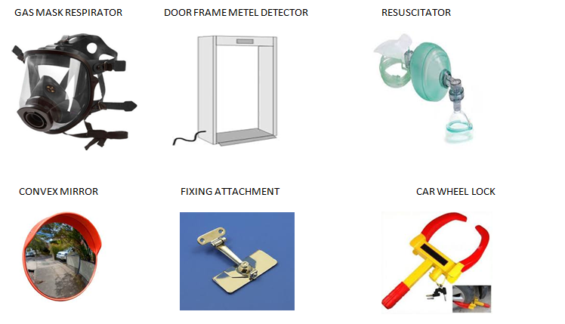

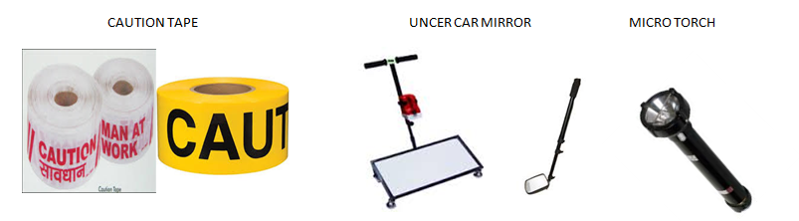

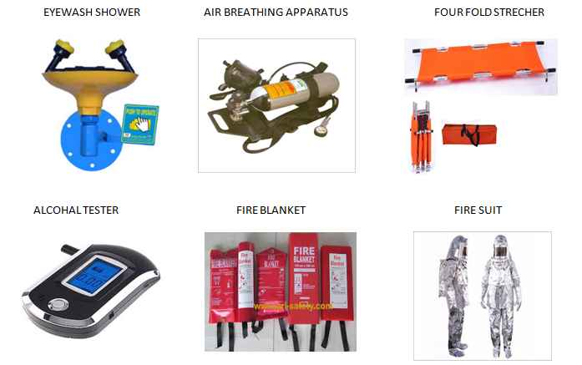

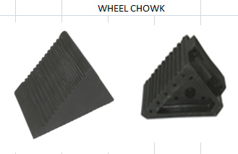
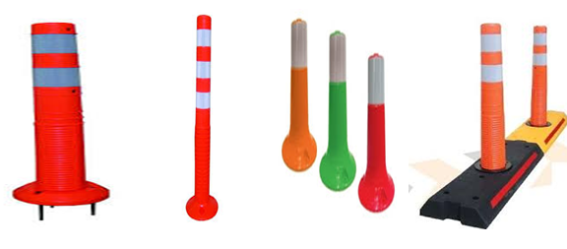
ROAD SAFETY

SAFETY SHOES
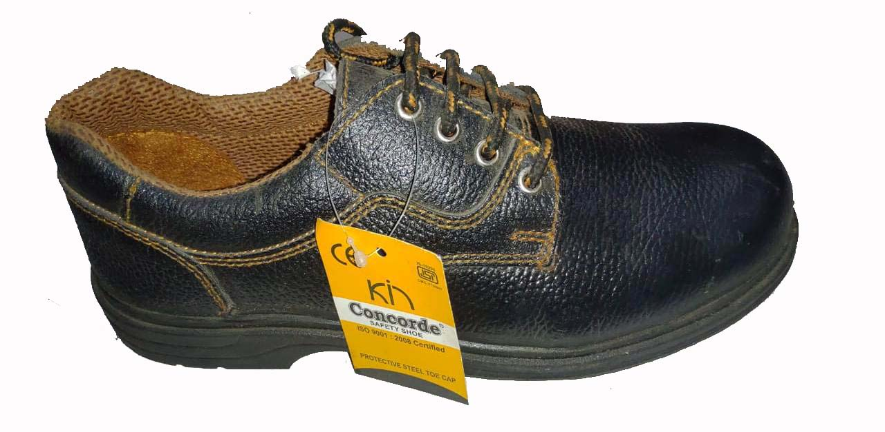

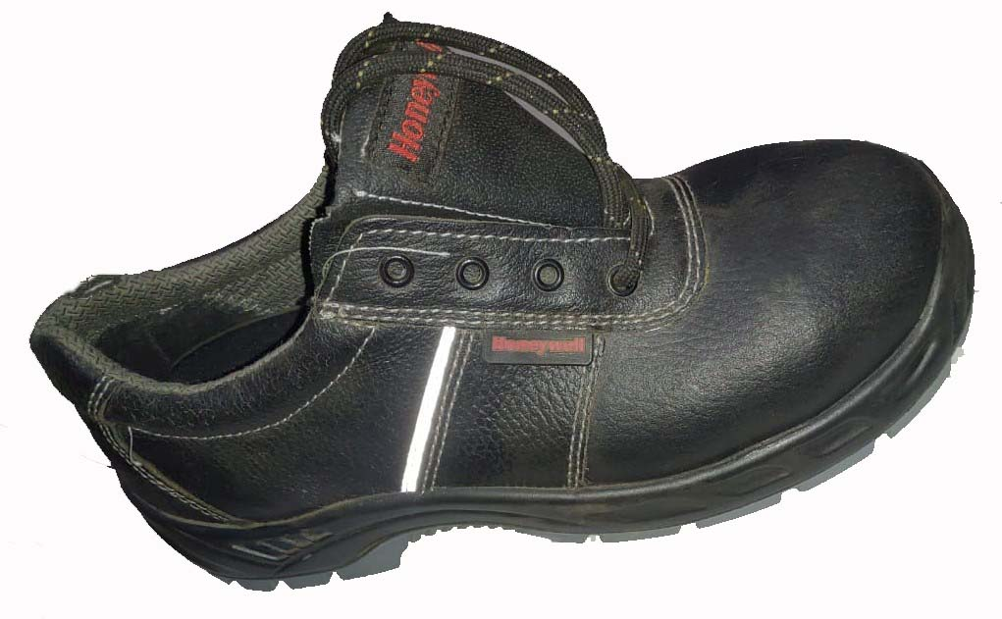

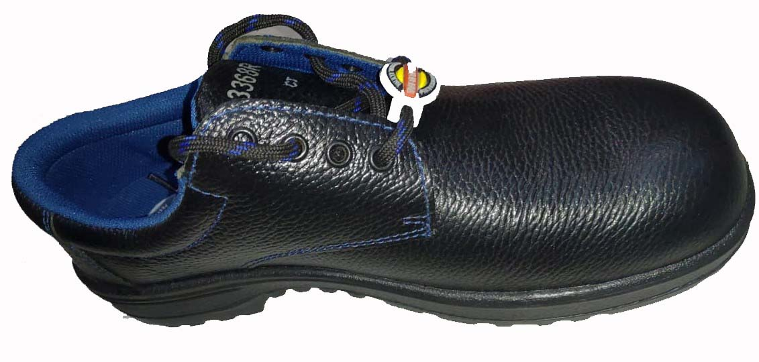

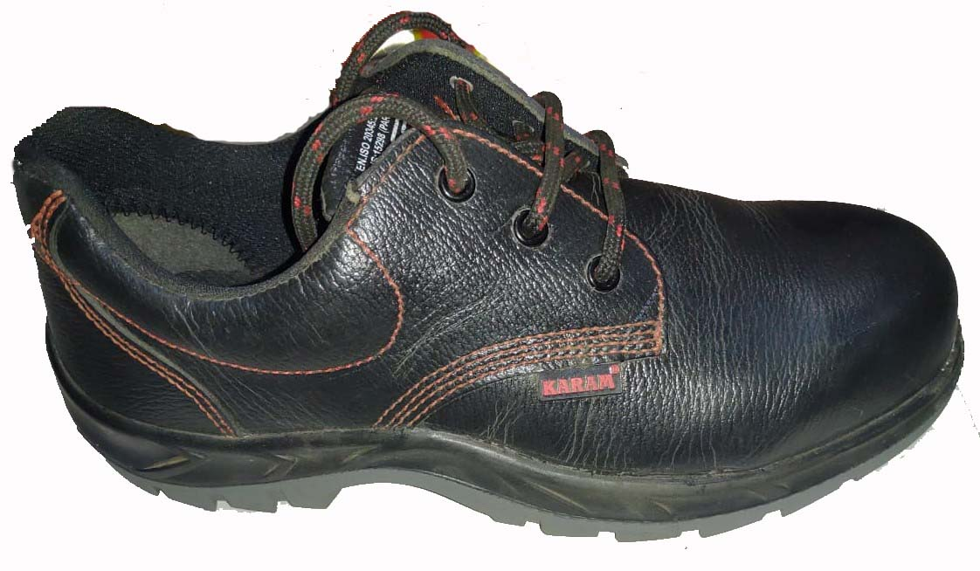

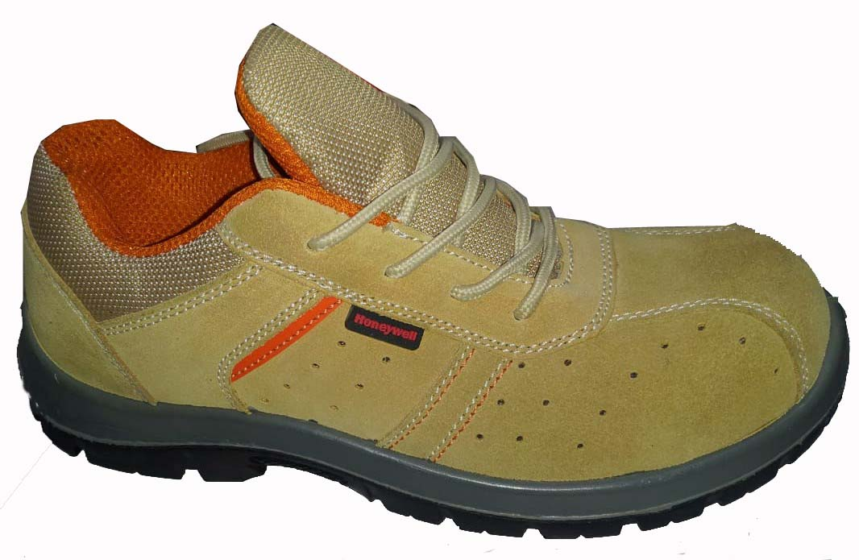

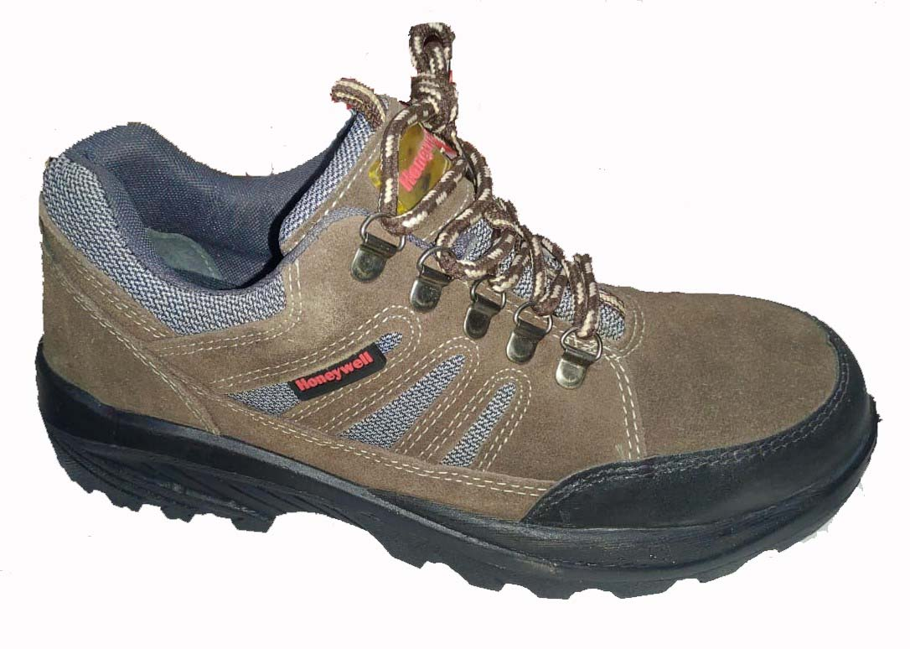

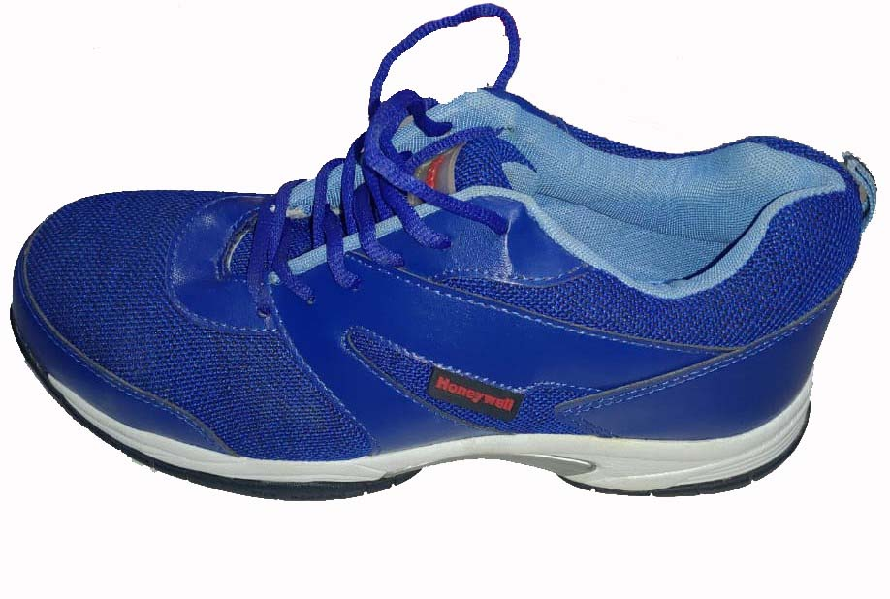
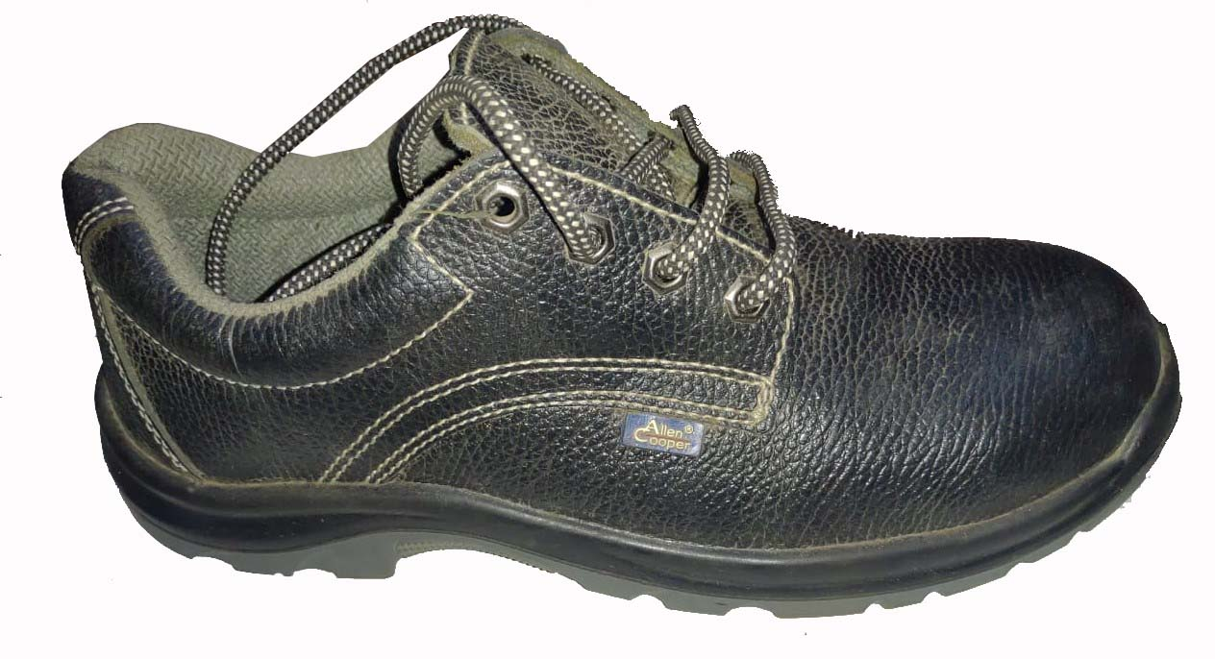

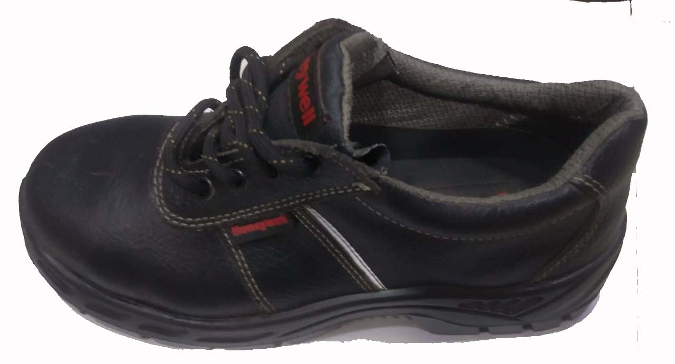

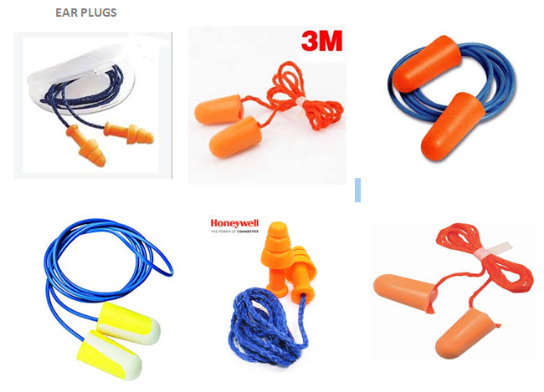
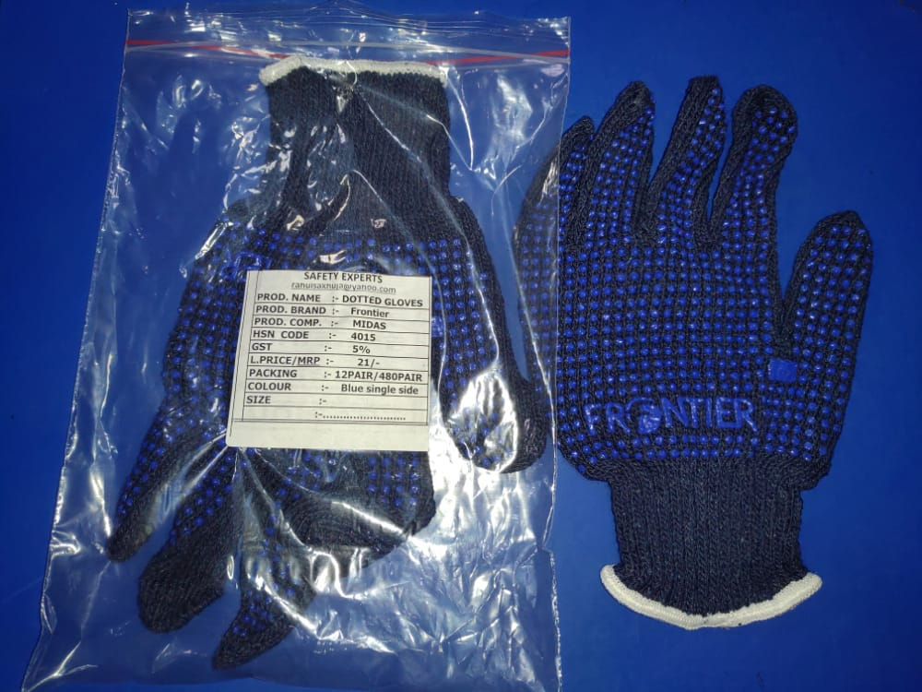
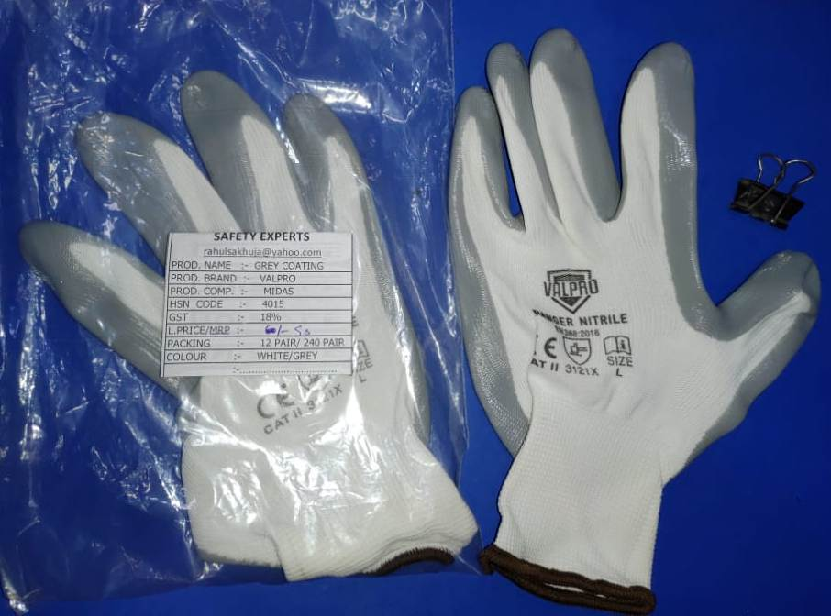
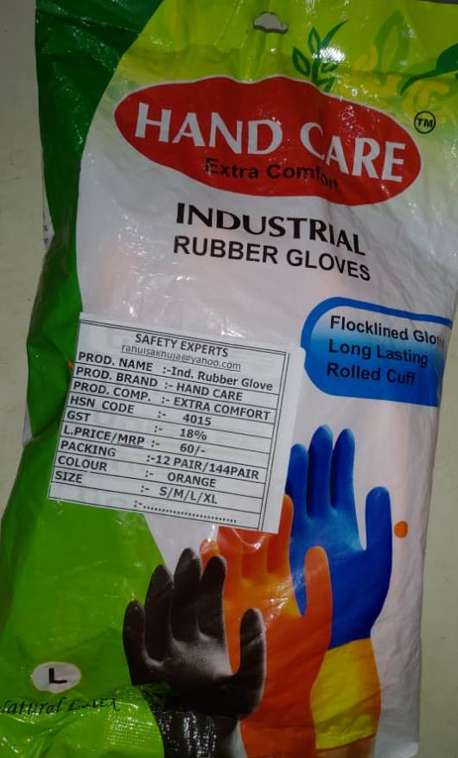
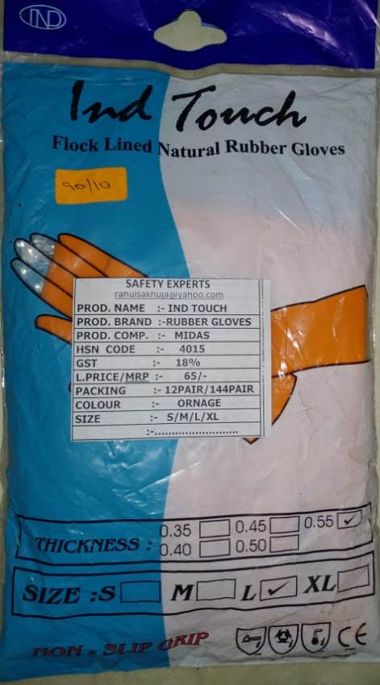
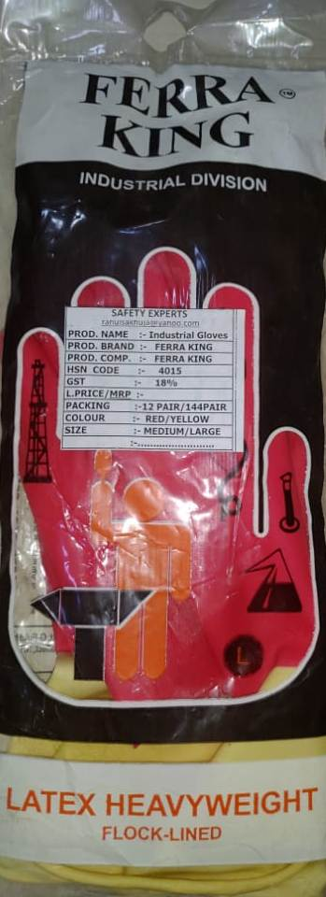
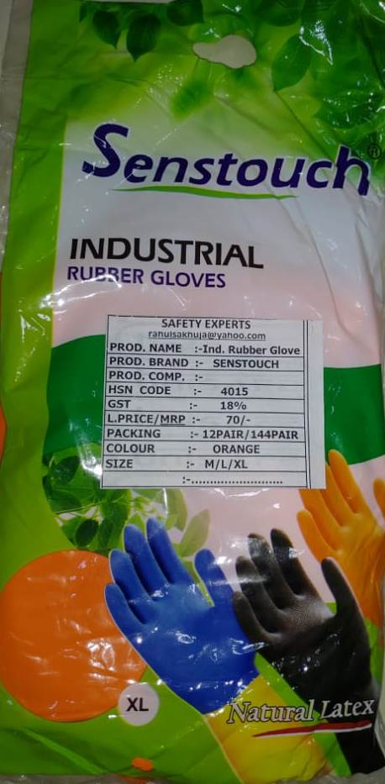
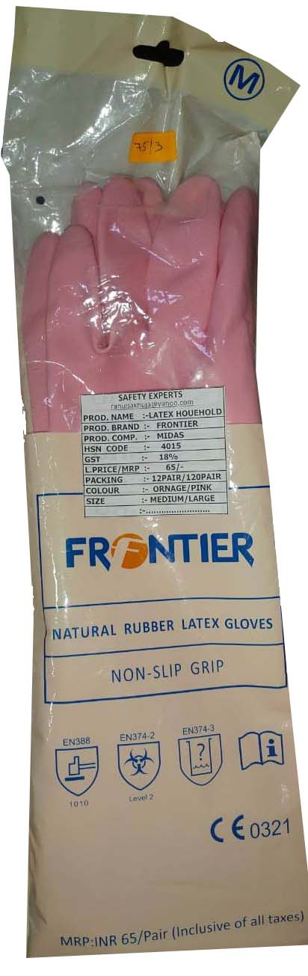
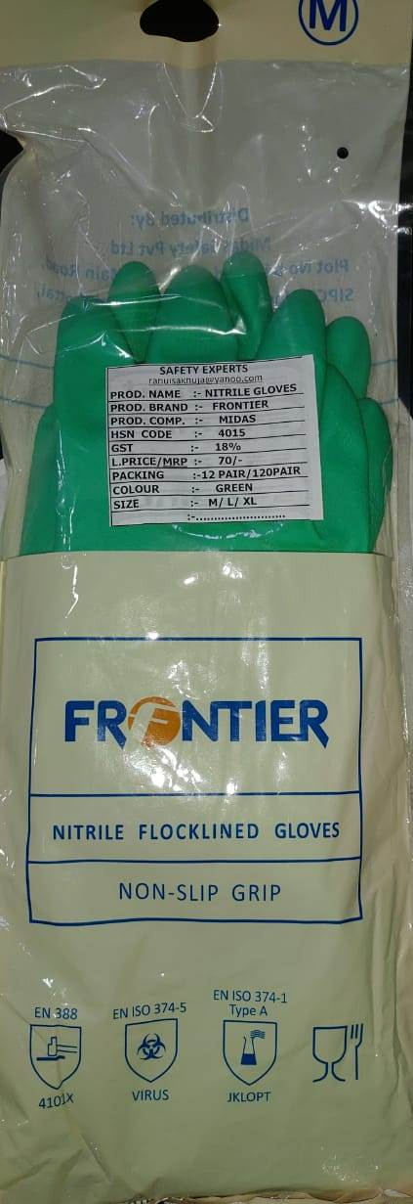
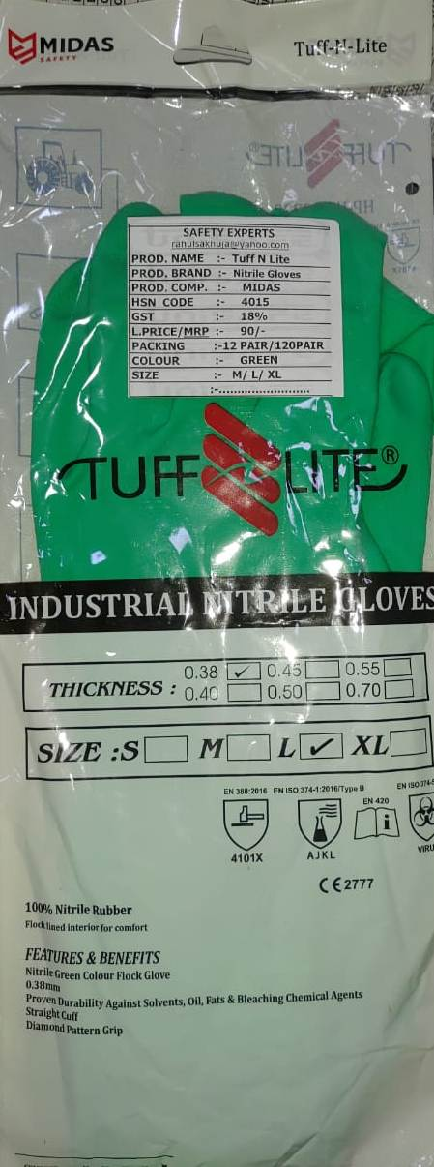
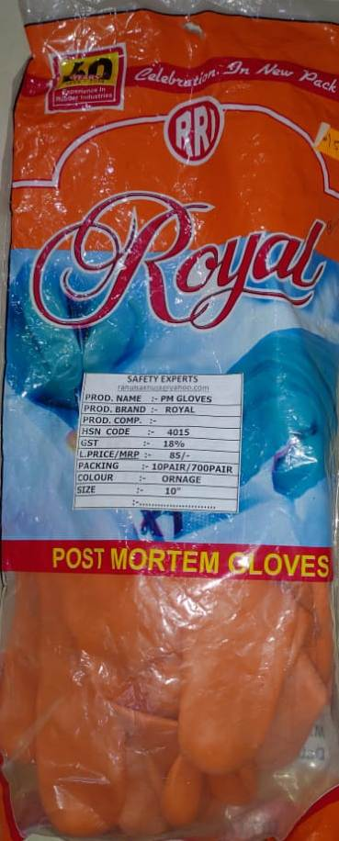
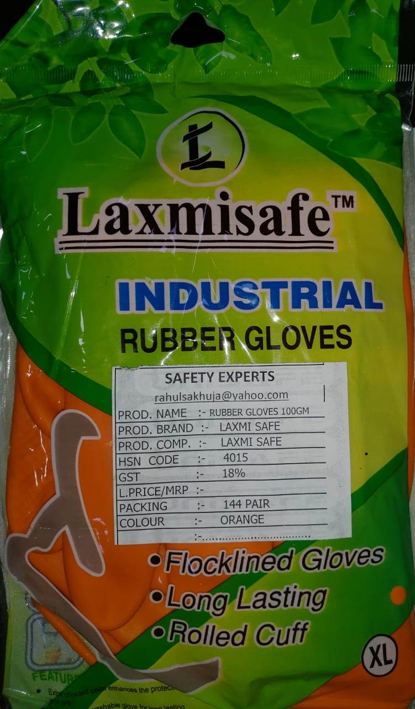
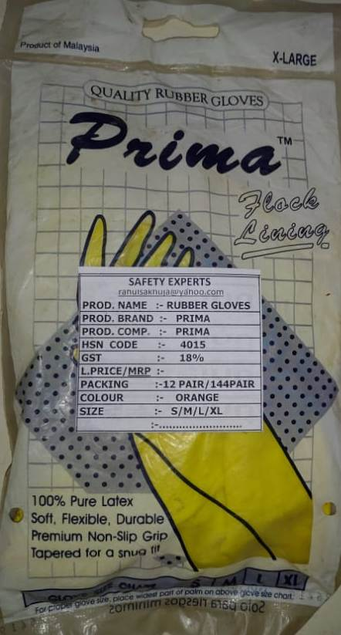
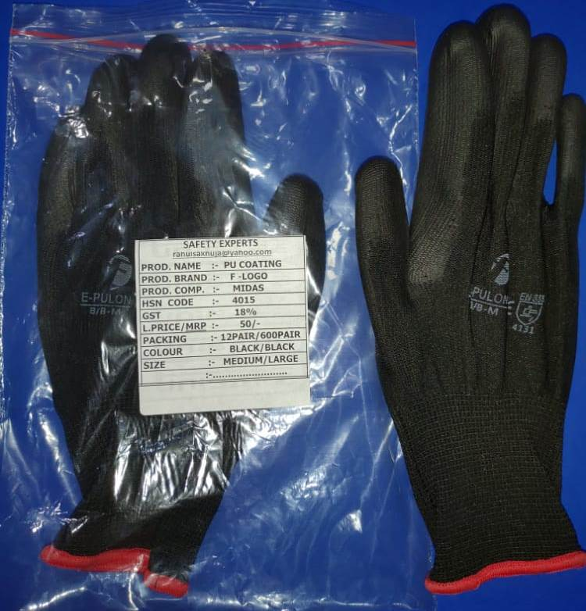
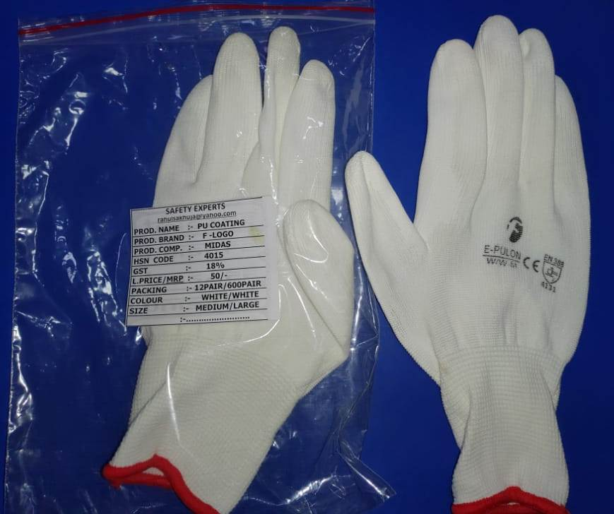
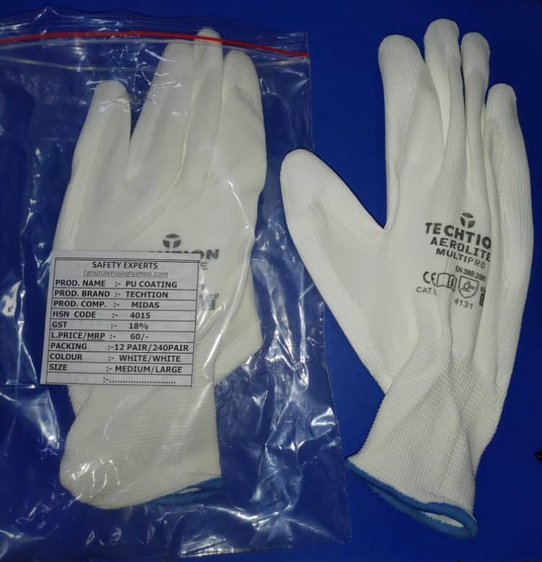
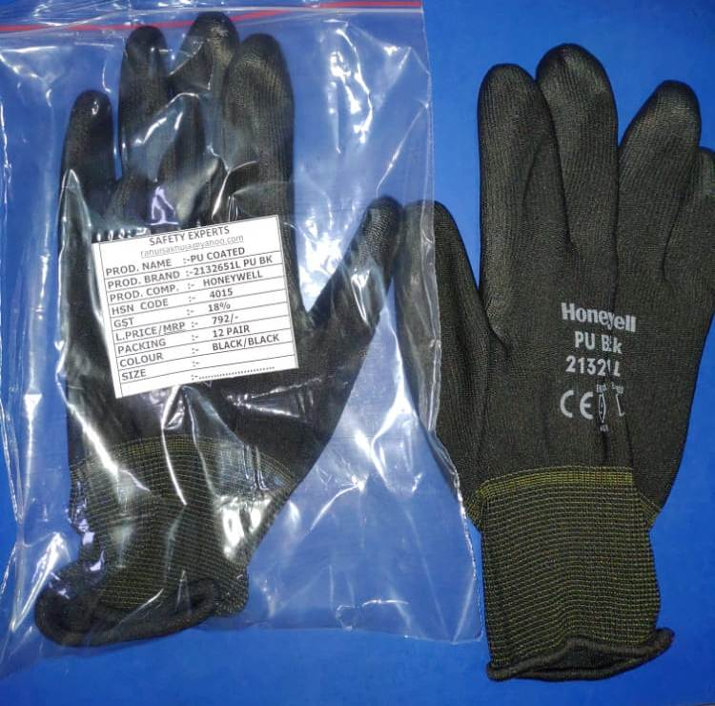

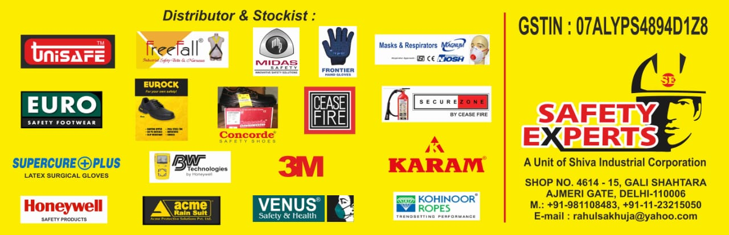
Brands we sale and Service :

